## **Part C – Questions Using the Library Database**

1. What are the 5 most popular books?
   * Show ASBN, Title.
   * HINT: To limit results use ROWNUM.

# Answer:

SELECT Book.ISBN, Book.TITLE, COUNT(*) AS Borrow_Count

FROM Book

INNER JOIN Loan ON Book.ISBN = Loan.ISBN

GROUP BY Book.ISBN, Book.TITLE

ORDER BY Borrow_Count DESC

OFFSET 0 ROWS FETCH NEXT 5 ROWS ONLY

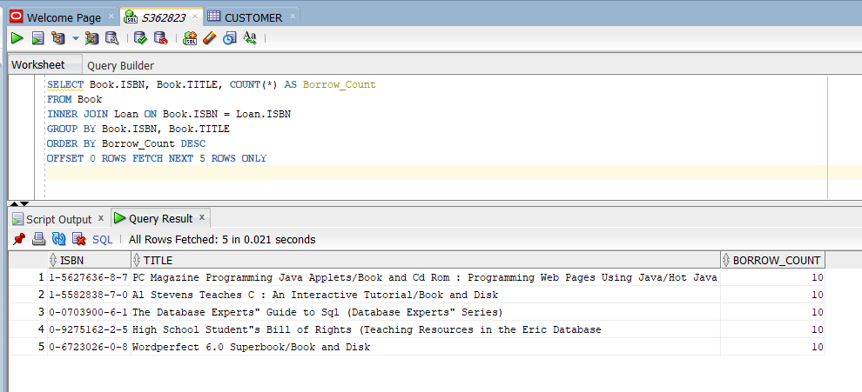

1. Which branches currently have no loans out?
   * Show all branch names.
   * List in ascending order by branch.

ANSWER:

SELECT Branch.BRANCHNAME

FROM Branch

LEFT JOIN Loan ON Branch.BRANCHID = Loan.BRANCHID

WHERE Loan.BRANCHID IS NULL

ORDER BY Branch.BRANCHNAME ASC;

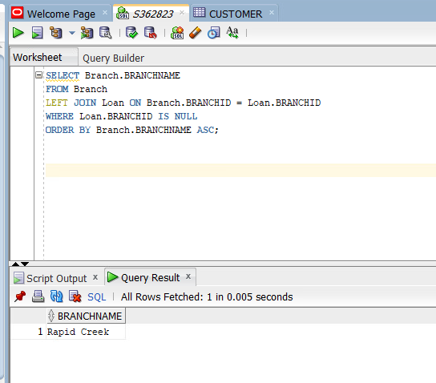

1. Find the **longest time** a book has been loaned out for each branch
   * Show only branch name and number of days.
   * List in ascending order by branch name.
   * Show all branches, even if there are no loaned out books. Therefore, a branch may have a null value for the longest loaded out book.
   * Format the number of days to one decimal place.

ANSWER:

SELECT Branch.BRANCHNAME,

ROUND(MAX(MONTHS_BETWEEN(loan.datein, Loan.DATEOUT) / 30), 1) AS Max_Loan_Period

FROM Branch

LEFT JOIN Loan ON Branch.BRANCHID = Loan.BRANCHID

GROUP BY Branch.BRANCHID, Branch.BRANCHNAME

ORDER BY Branch.BRANCHNAME ASC;

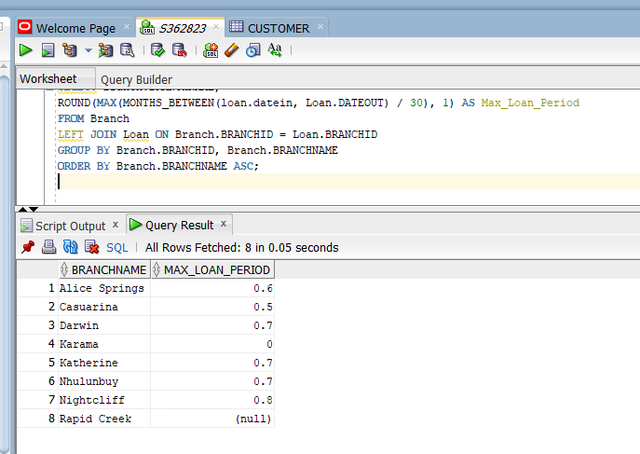

1. Find the borrower that has returned a book on the dated 16 December 2010 and 8 May 2012
   * Show two different methods.

ANSWER:

Method 1: Using a subquery.

SELECT *

FROM Borrower

WHERE CARDNO IN (

SELECT CARDNO

FROM Loan

where DATEIN IN ('16/DEC/10' , '08/MAY/10')

)

CAN ALSO DO IN THE FOLLOWING WAY:

SELECT *

FROM Borrower

WHERE CARDNO IN (

SELECT CARDNO

FROM Loan

WHERE DATEIN IN (TO_DATE('2010-12-16', 'YYYY-MM-DD'), TO_DATE('2012-05-08', 'YYYY-MM-DD'))

)

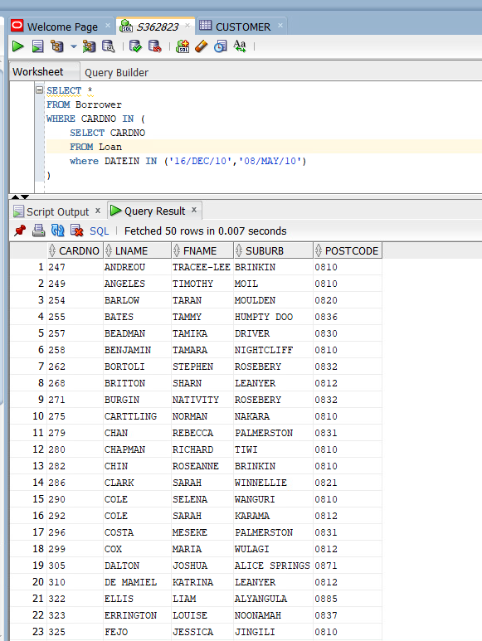

Method 2: Using a JOIN

SELECT DISTINCT Borrower.*

FROM Borrower

JOIN Loan ON Borrower.CARDNO = Loan.CARDNO

WHERE Loan.DATEIN IN (TO_DATE('2010-12-16', 'YYYY-MM-DD'), TO_DATE('2012-05-08', 'YYYY-MM-DD'))

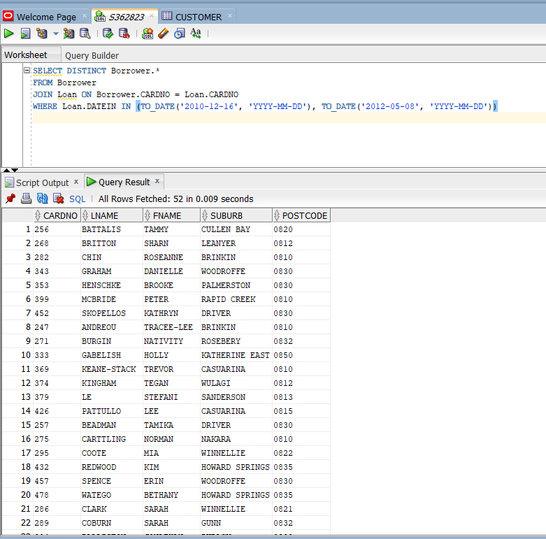

1. Devise a delete query, which will eliminate duplicates for customer columns `ID`,

`CustomerLastName`, `CustomerFirstName` and invoice columns `Invoice_Date` and

`Invoice_No`.

* + Ensure the query removes all duplicate data.

ANSWER :